**MEDICAL DEVICE INVENTORY MANAGEMENT FOR A MEDICAL ESTABLISHMENT NETWORK OF SERVICE PROVIDER**

**FINAL REPORT**

* ***Vineet L. Dandekar***

**PREFACE**

*Medical Device Inventory Management for a Medical Establishment Network of Service Provider is the topic of my choice as part of the final project for the Application Engineering & Development coursework. This document contains an initial research and background study of the most basic components that will be the part of the application system which this project is aimed at developing.*

*This document contains the basic architecture of the system, which includes a detailed object model that explains the flow of data around the system. This architecture design is based on several assumptions about various functionalities, information, background processes, etc. that are supposed to be involved in the working of the organization which is going to use the software application. The document lists down the assumptions made while designing the architecture of the system.*

**INTRODUCTION**

The Medical Device Inventory Management System is a standalone desktop application which will be used by large Healthcare Systems like the Partners Healthcare System to manage their inventory of large number of costly medical equipment. The basic purpose of this application is to provide an efficient solution for the hospitals, which are managed by the Partners Healthcare System, to share the costly medical equipment among each other, thus, eliminating the need to stock costly equipment which will not be used very often.

In addition to the inventory management feature, this system will also provide a platform for the various suppliers or the manufacturers of these medical instruments to manage their products and communicate with the healthcare system in order to fulfill their product orders.

Also, there is another feature that this system will provide. Medical clinicians working in the various hospitals associated with the healthcare system will be provided with a platform to manage their day-to-day activities such as scheduling a surgical operation or requesting to buy some new medical equipment. For scheduling a surgical operation, the clinicians will be required to reserve the required instruments, the operating room and a medical team in advance.

This introduction to the topic will be followed by some research about the healthcare system under discussion and its associated hospitals.

**PROBLEM STATEMENT**

Partners Healthcare System, Inc. is an integrated healthcare system that owns several hospitals in Massachusetts, mainly in the Boston area. These hospital offers a range of medical, surgical and specialty care, including maternity services, a 24-hour emergency department and orthopedic, critical care and oncology inpatient units.

In order to provide these medical, surgical and specialty care, the doctors of the hospital will require many basic as well as very sophisticated and costly **medical equipment**. Every hospital can manage the very basic instruments on their own, but purchasing and managing the more sophisticated instruments is proving to be a costly affair for the Partners Healthcare. The system has many hospitals associated with them, and purchasing these costly instruments separately for each hospitals is turning out to be a budget problem for the organization. This is the reason why the healthcare system wants to have a **central warehouse** for such costly instruments which can then be shared by the entire association of hospitals whenever required.

Also, doctors from the hospitals need a platform to schedule surgical operations by reserving the medical devices along with reserving the operating room and a team of medical staff who will assist him in the procedure. The system should provide this functionality as well.

The warehouse being the centralized repository for the entire healthcare system, it is solely responsible to manage and maintain the various medical devices. It also has the responsibility of purchasing new devices that are needed, may be to replace the old instruments or to add stock. For this purpose, the software system should also provide access to a list of **suppliers or manufacturers** of the medical devices. The suppliers can directly list their products using the software system. The warehouse manager can browse through the list offered by various suppliers and can place orders for the required products.

**PARTNERS HEALTHCARE**

Partners Healthcare System, Inc. is an integrated healthcare system that owns several hospitals in Massachusetts, mainly in the Boston area. Partners Healthcare is a not-for-profit organization which was founded by Brigham and Women’s Hospital and Massachusetts General Hospital, which are two of the nation’s leading medical centers. Along with the two founding academic medical centers, the healthcare system also includes primary care and specialty physicians, community hospitals, specialty facilities, community health centers and other health related entities.

**Massachusetts General Hospital,** one of the founders of the Partners Healthcare is the largest teaching hospital in Boston, Massachusetts. It is affiliated to the Harvard Medical School and is the third oldest general hospital in the United States. Partner’s second founder, **Brigham and Women’s Hospital** is also affiliated to the Harvard Medical School and is the second largest teaching hospital after Massachusetts General Hospital.

Along with these two founding hospitals, there are many community hospitals and medical centers which are associated with the Partners Healthcare System. One of such hospital is the **Newton-Wellesley Hospital**. Located in Newton, Massachusetts, the hospital offers a range of medical, surgical and specialty care, including maternity services, a 24-hour emergency department and orthopedic, critical care and oncology inpatient units.

In order to provide these medical, surgical and specialty care, the doctors of the hospital will require many basic as well as very sophisticated and costly **medical equipment**. Every hospital can manage the very basic instruments on their own, but purchasing and managing the more sophisticated instruments is proving to be a costly affair for the Partners Healthcare. The system has many hospitals associated with them, and purchasing these costly instruments separately for each hospitals is turning out to be a budget problem for the organization. This is the reason why the healthcare system wants to have a **central warehouse** for such costly instruments which can then be shared by the entire association for hospitals whenever required.

Other hospitals associated with the Partners Healthcare System are North Shore Medical Center, McLean Hospital, Martha’s Vineyard Community Hospital, Nantucket Hospital and many more. By sharing the costly devices among all these hospitals, a lot of money can be saved and used for other purpose rather than buying a large quantity of these medical devices for each of the hospitals and then not using them very frequently. But this idea will only work if it has an effective software system which will efficiently manage the centralized inventory. Doctors from the associated hospitals can schedule a surgical operation by reserving the medical devices which they will be requiring, well in advance.

Considering a surgical operation, medical devices are not the only things which are required by the doctors. Most importantly, they need an **operation room** and a **care team** to assist them in the procedure. The software system will allow the doctors to also reserve these operating rooms and the care team. The operating rooms and the care team will be specific to the hospital and not centralized as in case of the medical devices.

The warehouse being the centralized repository for the entire healthcare system, it is solely responsible to manage and maintain the various medical devices. It also has the responsibility of purchasing new devices that are needed, may be to replace the old instruments or to add stock. For this purpose, the software system will also provide access to a list of **suppliers or manufacturers** of the medical devices. The suppliers can directly list their products using the software system. The warehouse manager can browse through the list offered by various suppliers and can place orders for the required products.

This is the current scenario of the Partners Healthcare System, Inc. about how the software system will help them with their proposal of implementing a centralized repository. The next section contains the details or the business idea of the software system in more technical terms.

**SYSTEM DESIGN**

The software system will integrate the functionalities for several types of users working at different organizational levels. These users will be assigned different roles depending on their position within the organization and the work the user is assigned and authorized to do.

According to the ecosystem model, the Partners Healthcare, Inc. will represent the ecosystem and every other entity will be inside it. The ecosystem will have several networks where each network represent a single county in the state of Massachusetts. Each of these networks will have an association or a consortium of hospitals, a warehouse from which these hospitals will share devices from, and a list of suppliers from whom the warehouse will buy new devices from. Each hospital, warehouse and supplier will represent an Enterprise in the ecosystem model. Within each of these enterprises, there will be different organizations which will handle specific tasks within the enterprise. For example, a hospital enterprise will have two organization viz. Doctor Organization and Resource Organization. Each of these organization will have a list of users associated with it, who will be assigned roles and granted privileges according to the type of the user. This system is entirely a role-based system which will provide different interfaces according to the type of user using it.

Based on the problem statement, and the research and analysis on the problem, following roles have been proposed:

1. System Administrator
2. Hospital Administrator
3. Doctor
4. Resource Manager
5. Warehouse Administrator
6. Inventory Manager
7. Supplier Administrator
8. Product Manager
9. Sales Manager

**ROLE-BASED FUNCTIONALITY**

* **System Administrator –**
* Initially configures the system by creating a system administrator account.
* Creates and manages different networks.
* Creates and manages different enterprises within each network.
* Creates administrator accounts for each enterprise.
* View overall reports.
* **Hospital Administrator –**
* Manage different organizations within hospital.
* Add and manage users within each organization.
* View reports specific to the hospital.
* **Doctor –**
* Requests resource manager to schedule a surgical operation
* View its surgical schedule
* **Resource Manager –**
* Adds and manages operating rooms
* Adds and manages medical staff
* Schedules surgical operations
* Requests warehouse to buy new devices.
* **Warehouse Administrator –**
* Manages different organizations within warehouse.
* Add and manage users within each organization.
* View reports specific to the warehouse.
* **Inventory Manager –**
* Manages products in the inventory.
* Schedules maintenance for the inventory items
* Processes order request received from hospitals.
* **Supplier Administrator –**
* Manages different organizations within warehouse.
* Add and manage users within each organization.
* View reports specific to the supplier.
* **Product Manager –**
* Adds and manages products.
* Processes order request from the warehouse.
* **Sales Manager –**
* Request for payments from the warehouse
* Processes the payments received from warehouse.

**DETAILED OBJECT MODEL**

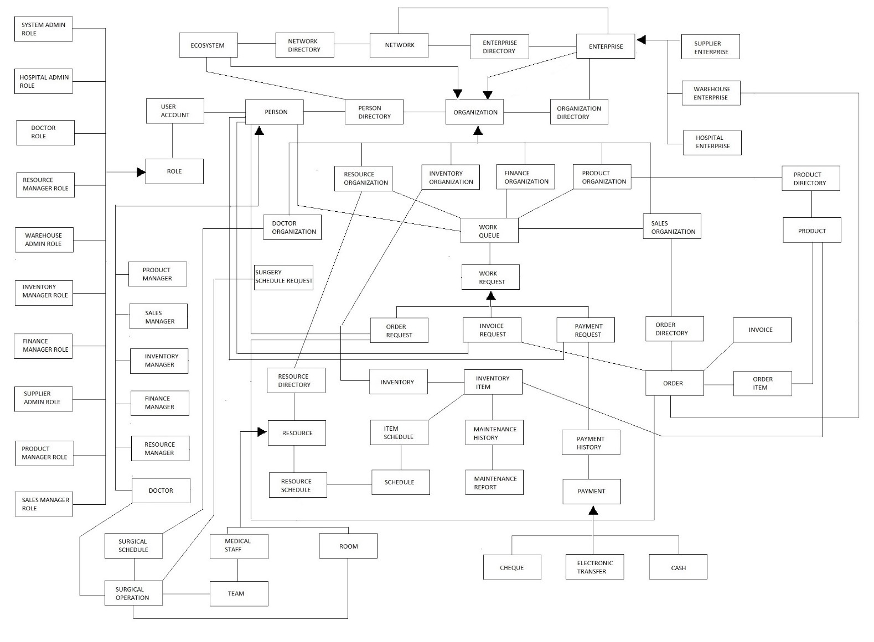

**REFERENCES**

1. http://www.partners.org/About/Company-Information/Default.aspx
2. http://en.wikipedia.org/wiki/Partners_HealthCare
3. http://en.wikipedia.org/wiki/Massachusetts_General_Hospital
4. http://en.wikipedia.org/wiki/Brigham_and_Women%27s_Hospital
5. http://en.wikipedia.org/wiki/Newton-Wellesley_Hospital